1. Eligibility
- The submission (scripted fiction of any genre) must have been originally created or aired on television, internet or video platform. However,promo reels or drama commercials and promotional materials are excluded.
- The submission has initially been broadcast or released in any country between the dates of May 1, 2019 and April 30, 2020.
- The entering organization or individual holds copyright ownership OR obtains consent from the rights owner before presenting a submission
Notices regarding copyrights during submission
- In the case of a joint production, the entrant must notify the production partner company beforehand.
- Resubmitted entries will be disqualified. In the event a program is submitted by more than one entrant, the entrants which hold the copyright must decide which submission should be used and inform the Organizing Committee.
- In the event regarding issues related to copyright, entrant must take full responsibility.
- Eligibility will be considered on a case-by-case basis.

2. Categories
 | Awards  Category | Definition
Program | TV Movie | A production from one (1) and two (2) episodes.  ※ If the program is part of an anthology series (Independent story, characters within a series), each program will be approved as a separate TV Movie submission.
 | Mini-Series | A production between three (3) and twenty four (24) episodes.  ※ If the submission tends to be a series and qualifies, each series is counted as an independent submission.
 | Serial Drama | A production with twenty five (25) or more episodes in which theme, storyline and main characters are presented under the same title.
 | Short Form | A production consists of episodes under approximately 30 minutes in length and produced with digital platform as target audience and platform.  ※ There is no limitation in number of episodes, but only one submission can be made in each categories.
※ Once a program is submitted, it will automatically be competing in the Individual category. The entrant MUST request to the Organizing Committee to exclude specific Individual categories if they do NOT wish to compete in them and be nominated.

3. Awards Category
- Competition Category
- Program Category : Grand Prize (1), TV∙Mini-Series∙Serial Drama (2 each), Short Form (1)
- Individual Category (4) : Best Actor (1), Best Actress (1), Best Director (1), Best Screenwriter (1)
- -Jury’s Special Prize
- Non-Competition Category
- The Most Popular Foreign Drama of the Year, Asian Star Prize, Outstanding Korea Drama Prize

4. Required Materials : Completed online entry form, photo, video (English subtitles), consent form of the submission
  - Entry Form : Online submission on the Seoul International Drama Awards official website
http://www.seouldrama.org/EN/entry/Awardsaccountinfo.aspx

Notification
• Entry forms must be submitted in English.
• Entrants must submit correct information. In the event of a disadvantage caused due to false information, the Organizing Committee will not be responsible.

- Digital Photos: All image files must be uploaded on the online entry form
1) One (1) official poster (mandatory)
2) Headshot of talent: Up to 2 headshots for actor and actress (each) can be submitted (mandatory)
3) Headshot of screenwriter OR director: Up to 2 headshots for screenwriter and director (each) can be submitted.
4) Digital Photo File Format
- Resolution of 1600 x 1200 px, or JPEG form file of 300 DPI
- Each photo you save must be less than 5MB
5) Should there be technical difficulties, entrant may contact the Organizing Committee
and submit separately.

- Video: Videos that are prepared to the regulation can be submitted in two (2) ways.
- Upload on the official google drive account of the Organizing Committee: seouldramaawards@gmail.com
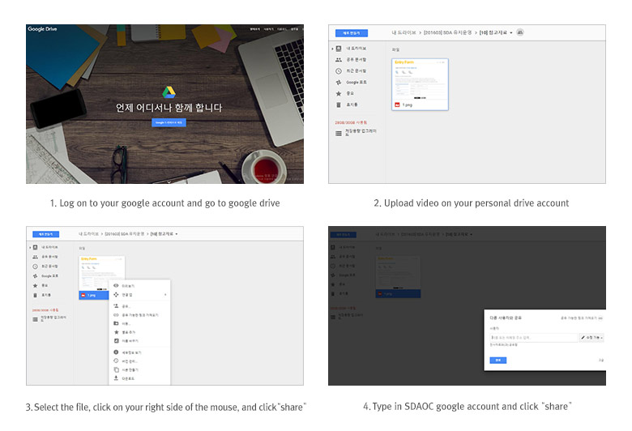
2) Save the video files on a USB flash drive and ship it to SDAOC.
※ Video file
Category | Video file
TV Movie | Trailer under  five (5)  minutes | The entire film or both parts (two episodes) must be submitted.
Mini-Series |  | First and last episodes must be submitted. To help  understand the flow of the story, one (1) additional episode must be submitted.
Serial Drama |  | First and last episodes must be submitted. To help  understand the flow of the story, two (2) or three (3) additional episodes must be submitted.
Short Form |  | First and last episodes must be submitted. To help  understand the flow of the story one (1) additional episode must be submitted.
※ Criterion
• Video Format
① Video codec : H. 264, ② Audio codec: AAC, ③ File formats : MP4, MOV, AVI, WMV (Any format is acceptable as long as the provided codecs/formats are readable on default and 3rd-party video players) ④ Resolution : 1280×720 HD (16:9 ratio)
• All programs must be subtitled in English. Programs without subtitles will automatically be refused
• It is recommended to submit an english script with the video file.

- Consent form of the submission: Select while submitting online entry form
1) Usage of submission
The Seoul Drama Awards constantly strives to create a place where diverse people from various countries can gather, communicate, and exchange beyond the borders and cultural barriers. In order to utilize and promote (within Korea) of high-quality dramas from around the world, the Seoul International Drama Awards seeks to get an agreement for future purposes. Please select the following range of consent and submit the online entry form.

2) Options of submission usage (multiple selections are available)
 | Submission Scope of Usage
Requirements | The SDAOC is entitled the right to editing and extracting excerpts from entries for all TV, Internet, and exhibitions hosted by the SDA. (Excerpt is maximum 15 minutes)
Opt. 1 | To host the TV Movie Premiere organized by the SDAOC, the Organizing Committee is entitled the right to publicly screen the submitted video file in public within 15 times in South Korea. + Requirements (Above)
Opt. 2 | During the limited period of 2 weeks (14 days) that the SDAOC plans, two (2) episodes (VOD) will be provided under a limited screening condition in Korea via online, IPTV etc + Requirements (Above)
Opt. 3 | During the limited period of 2 weeks (14 days) that the SDAOC plans, the entire series (all episodes of VOD) will be provided under a limited screening condition in Korea via online, IPTV etc + Requirements (Above)

3) The Duty of Seoul Drama Awards Organizing Committee
The submissions should be strictly used for the purpose of promoting the awards ceremony and the exhibitions only in accordance with the consent of the entrants. The Organizing Committee must strictly control the violation of copyrights, or illegal leakage of any kind.

5. Entry Deadline : May 8, 2020

※ Shipping Method (Optional)
• Uploading on Googledrive
Please share the file with the official account of SDA: seouldramaawards@gmail.com
• Shipping by post (USB stick)
Seoul Drama Awards Organizing Committee / Korean Broadcasters Association
10th FL. Korean Broadcasters Center Bldg. 233 Mok-dongdongro, Yangcheon-gu,
Korea (Postal Code: 07995)
Seoul International Drama Awards (02-3219-5585)

※ The Organizing Committee reserves the right to approve or deny an extension request on submissions, as well as determine its length if granted.

6. Notification
  - No entrance fee is required, and there is no limit to the number of submissions according to each category.
  - The Organizing Committee is not obliged to return any submitted materials.
C. The Organizing Committee has rights to request additional materials, due to lack of information or technical errors. In the case of a nomination, entrant must co-operate fully.
D. For INDIVIDUAL categories (Actor & Actress), the entrant must notify the entered performers of submission and the Awards date in advance and must co-operate to the fullest so talents can attend the awards ceremony..

7. Judging Procedures
A. Preliminary Selection: Panel of 9 international professionals
- Each judge individually screens and evaluates the entries. After the Organizing Committee collects official ballots from the jury, top ranking entries become nominees.
B. Final Selection: Panel of 7 international professionals
- Each judge individually screens and evaluates the nominated works. After the Organizing Committee collects official ballots from the jury, top ranking programs and individuals from among the nominees become the final winners.

8. Announcement
- Nominees: The Organizing Committee will announce the nominees on the website and notify the entrants individually after preliminary selection.
- Winners: The winners will be announced at the live-telecast Awards Ceremony in September 2020 in Seoul.

9. Inquiries
Seoul Drama Awards Organizing Committee:
Na-Eun Kim kne@kba.or.kr / Tel : 02-3219-5585
Ji-Yeon Shin modi17@kba.or.kr / Tel : 02-3219-5568

