2021. 04. 07

The 16th Seoul International Drama Awards Entry Submission D-30

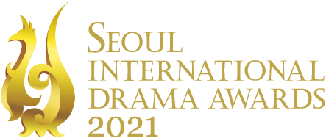

The entry submission of the Seoul International Drama Awards 2021 (SDA), the only international drama festival in South Korea is about one month away.
The Seoul International Drama Awards 2021, hosted by the Seoul International Drama Awards Organizing Committee and the Korean Broadcasters Association and sponsored by the Ministry of Culture, Sports and Tourism, and the Seoul Metropolitan Government, has begun its international competition submission in March and the deadline of submission is set on May 7. The submission should have initially been broadcast or released in any country between the dates of May 1, 2020, and April 30, 2021. Entrants can submit the submission materials by mail or Google Drive after applying online entry forms on our official website(http://www.seouldrama.org/eng/) by the 7th of next month.
For more information on the 16th Seoul International Drama Awards, visit the SDA website.

###

Media Enquiry
The Seoul International Drama Awards Organizing Committee
Na-Eun Kim T. +82-2-3219-5585 / M. +82-10-8861-8401 / Email. kne@kba.or.kr
Yeon-Soo Choo T. +82-2-3219-5572 / M. +82-10-8577-1436 / Email. chewie17@kba.or.kr
Da-Yeon Kim T. +82-2-3219-5571 / M. +82-10-8983-5109 / Email. dayeon.kim@kba.or.kr

Introducing the Seoul International Drama Awards 2021
The Seoul International Drama Awards 2021, hosted by the Seoul Drama Awards Organizing Committee and the Korean Broadcasters Association and sponsored by the Ministry of Culture, Sports and Tourism, and the Seoul Metropolitan Government, was founded in 2006. This year marks the 16th year, and the SDA is a celebration for television experts and fans from all around the world.
The awards category includes International Competition, International Invitation, and Outstanding Korean Drama, and the entrant can submit the entries for TV Movie, Mini-Series, Serial Drama, and Short-Form in the International Competition category. The Grand Prize will be given to one drama with the most outstanding artistry, originality, and popularity among the categories: TV Movie, Mini-Series, Serial Drama, and Short-Form.

